Contact
[Company Name] | [Company Address]
MICROWAVE NETWORK PLANNING & DESIGN SERVICES
Technical Capability & Methodology Overview
Table of Contents
ABSTRACT 2
EXECUTIVE SUMMARY 3
Document Purpose and Scope 3
Customer Network Characteristics 3
Service Delivery Approach 3
MICROWAVE TECHNOLOGY ADVANTAGES & CAPABILITIES 4
Flexible Propagation Modes 4
Modern Microwave Technical Capability Summary 5
PLANNING TOOLS & TECHNOLOGY STACK 6
Professional Planning Software Selection 6
Terrain Data Strategy 7
Site Survey Equipment and Methodology 7
Standards Compliance Framework 8
EQUIPMENT VENDOR RECOMMENDATIONS 8
Vendor Selection Criteria 8
Per-Link Equipment Breakdown 9
Capacity Planning for 100/20 Mbps Service 9
Equipment Selection by Link Distance 9
Network Topology Strategy 10
PLANNING & DESIGN METHODOLOGY 10
Six-Phase Delivery Process 10

ABSTRACT
This document presents a comprehensive technical overview of microwave network planning and design services for hybrid fiber-microwave transport networks. It is specifically tailored for rural greenfield deployments delivering 100 Mbps download / 20 Mbps upload broadband services, with particular emphasis on leveraging existing tower colocation opportunities to optimize capital expenditure.
The document details the complete end-to-end planning and design methodology following industry-proven practices, covering six distinct phases from initial requirements gathering through final design documentation and Bill of Materials (BOM) preparation.
Key topics include professional planning tools and software, recommended equipment vendors and technology platforms, network topology options, site and path survey procedures, detailed link engineering calculations, FCC frequency coordination processes, and quality assurance methodologies based on ITU-R international standards.
The document concludes with a transparent cost structure for planning and design services, equipment cost estimates, and a complete deliverables summary. All technical content is presented to enable informed decision-making regarding network architecture, technology selection, and project scope definition.
This capability overview serves as both an educational resource and a technical reference for evaluating microwave transport network design services.

EXECUTIVE SUMMARY

Document Purpose and Scope
This document presents a comprehensive technical capability overview for microwave network planning and design services. It is specifically prepared for hybrid fiber-microwave transport network deployments supporting high-speed broadband services in rural and underserved markets.
The scope of services covered includes:
- Complete microwave network planning and engineering
- Site and path survey methodology
- Detailed link design and frequency coordination
- Equipment selection and Bill of Materials (BOM) preparation
- Design documentation ready for procurement and deployment
This document does not cover network deployment, installation, or commissioning services. It focuses exclusively on the planning and design phase, delivering comprehensive technical documentation and procurement-ready specifications.

Customer Network Characteristics
Attribute | Details
Deployment Type | Greenfield hybrid fiber-microwave network
Market Segment | Rural broadband access
Service Profile | 100 Mbps download / 20 Mbps upload per subscriber
Infrastructure Strategy | Leverage fiber where available; deploy microwave where fiber is not economically feasible
Tower Colocation | 60% of sites will utilize existing tower infrastructure (American Tower, Crown Castle, SBA Communications)
New Infrastructure | 40% of sites require new mounting structures

Service Delivery Approach
The planning and design service follows a proven six-phase methodology aligned with international telecommunications industry best practices
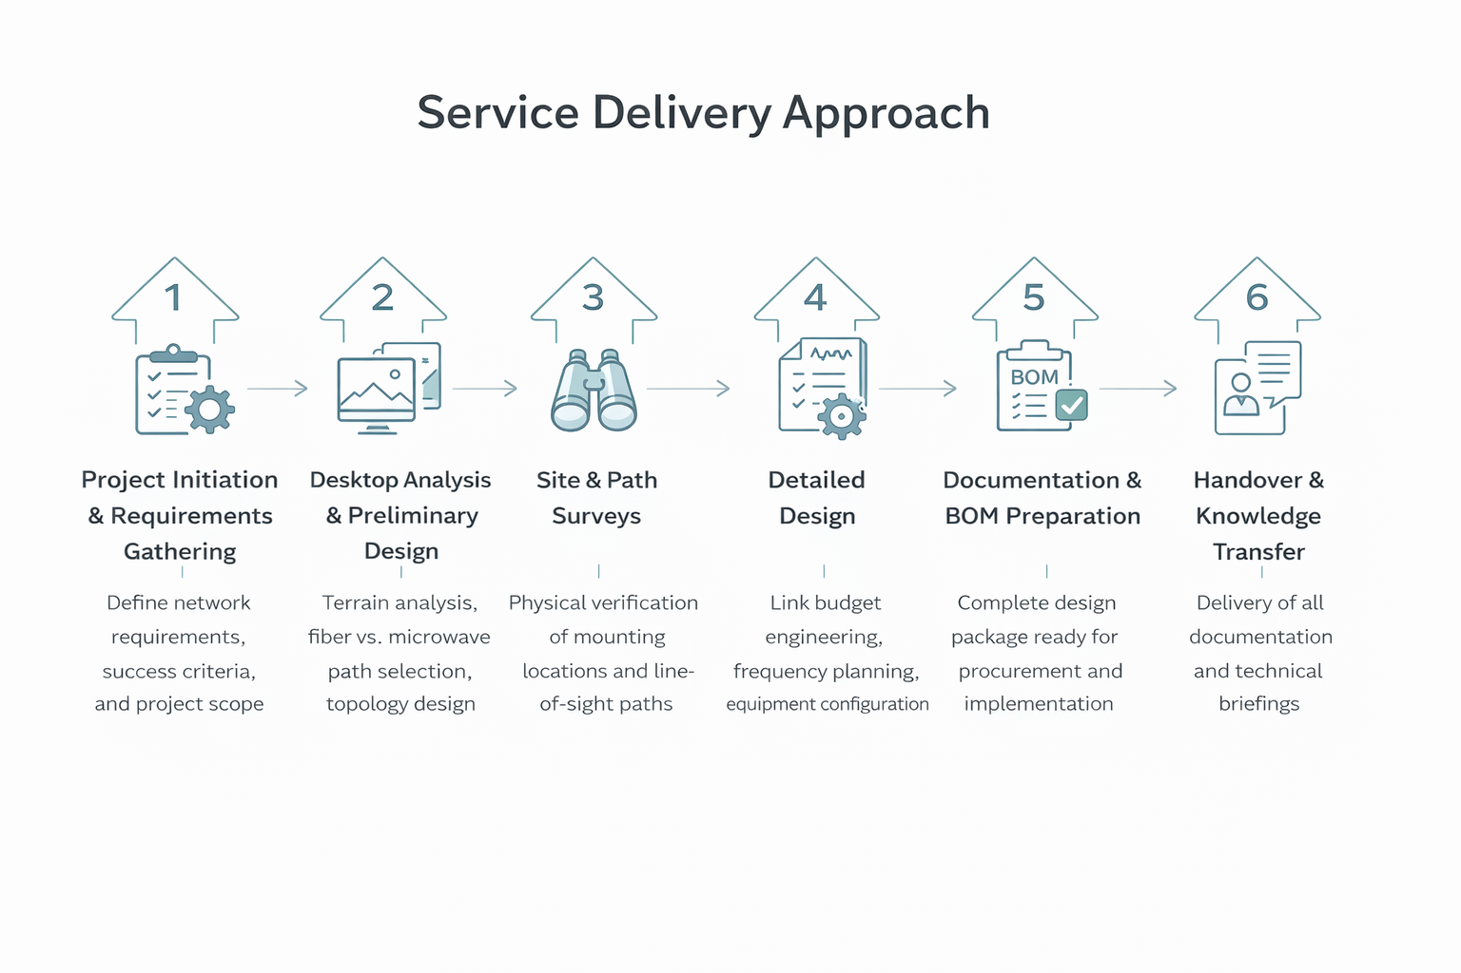

MICROWAVE TECHNOLOGY ADVANTAGES & CAPABILITIES
Modern microwave transmission systems offer compelling technical and economic advantages for rural broadband transport networks:

Flexible Propagation Modes
Traditional microwave deployment required perfect line-of-sight between endpoints, limiting site selection flexibility. Modern systems operate across three distinct propagation modes, enabling connectivity in scenarios previously requiring fiber construction. Line-of-sight delivers maximum range and capacity for backbone applications, while near line-of-sight handles partial obstructions common in rolling terrain or light vegetation. Non-line-of-sight capability via MIMO technology enables urban deployments where building obstructions prevent direct visibility, expanding microwave applicability beyond traditional tower-to-tower links.
Type | Path | Range | Capacity | Reliability
Line-of-Sight (LOS) | Direct optical path | Up to 50+ miles (frequency dependent) | Up to 40 Gbps per link (80 GHz E-band) | 99.99%+ availability with proper design
Near Line-of-Sight (nLOS) | Partial obstruction with diffraction or reflection | 1-5 miles typical | 100 Mbps to 2 Gbps
Non-Line-of-Sight (NLOS) | Multi-path propagation without direct visibility | 0.3-3 miles | 50 Mbps to 500 Mbps

Capacity by Frequency Band:
Microwave link capacity depends on multiple interrelated factors rather than fixed frequency-to-bandwidth mappings. Channel bandwidth allocation (measured in MHz) establishes the theoretical maximum throughput, while modulation scheme selection (QPSK through 1024-QAM) determines spectral efficiency within that bandwidth. Higher-order modulation delivers greater capacity but requires stronger received signal levels and fade margins. MIMO configurations (2x2, 4x4) and cross-polarization techniques (XPIC) multiply baseline capacity by exploiting spatial diversity or dual polarization. Adaptive modulation automatically adjusts these parameters based on real-time link conditions - operating at maximum capacity during clear weather and gracefully reducing throughput during rain fade to maintain connectivity.
Frequency Band | Typical Range | Capacity Range
6 GHz | 10-30 miles | 50-500 Mbps
11 GHz | 5-15 miles | 100 Mbps-1 Gbps
18 GHz | 3-10 miles | 500 Mbps-2 Gbps
23 GHz | 1-5 miles | 1-4 Gbps
38 GHz | 1-3 miles | 2-6 Gbps
60 GHz (V-band) | 0.3-1.5 miles | 1-10 Gbps
70/80 GHz (E-band) | 0.5-3 miles | 10-40 Gbps
Frequency band selection primarily influences achievable range and antenna sizes rather than capacity per se. Lower frequencies experience less atmospheric absorption and rain attenuation, enabling longer links with smaller fade margins. Higher frequencies require larger fade margins for equivalent availability but support wider channel bandwidths in licensed allocations. The table below shows typical capacity ranges achievable with modern equipment and standard channel allocations, recognizing actual performance varies based on specific equipment capabilities, channel bandwidth licensing, modulation schemes deployed, and link engineering parameters.
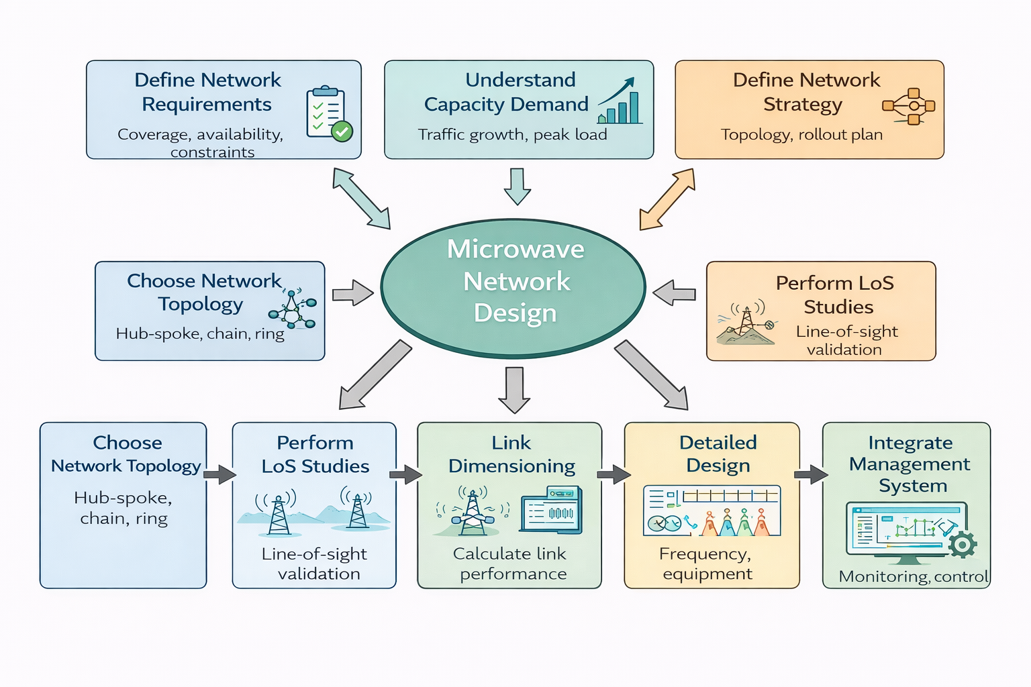

Modern Microwave Technical Capability Summary
Feature | Details
Propagation flexibility | LOS, nLOS, NLOS scenarios
Low latency | <2 ms, suitable for real-time applications
Protocol agnostic | Ethernet, IP/MPLS, TDM, Carrier Ethernet
MIMO capacity boost | 2-4x spectral efficiency
Scalable capacity | 100 Mbps to 40 Gbps per link
Licensed spectrum | Interference-free, ~$120/year per link
Rapid deployment | 3-4 months vs. 12-18 months for fiber
Carrier-grade reliability | 99.9%-99.999% availability
Cost efficiency | 90%+ savings vs. fiber in rural scenarios
Future-proof | Software-upgradeable capacity

PLANNING TOOLS & TECHNOLOGY STACK

Professional Planning Software Selection
Accurate microwave network design depends on specialized planning tools that integrate terrain analysis, propagation modeling, and regulatory compliance calculations. The software selection directly impacts design accuracy, project timeline, and FCC licensing success. Three primary options exist in the market, each serving different project requirements and budget constraints.
Software Platform Comparison
Criteria / Tool | Pathloss | Citadel Microwave Planning Tool | Aviat Design Tool | MLinkPlanner | CloudRF | RadioMobile / QRadioLink (Free)
Primary Strength | High-accuracy link budget & path profiling | Enterprise microwave planning & frequency coordination | Microwave planning aligned to Aviat radios | Focused PtP / PtMP microwave design | Cloud-based RF & microwave feasibility | Basic RF/microwave path analysis
Propagation Models | ITM / Longley-Rice | ITU-R, ITM, regulatory models | Standard microwave models | Standard models | ITM + cloud models | ITM / basic models
Link Budget Engineering | Excellent (industry benchmark) | Strong | Good (vendor-specific) | Good | Moderate | Basic (manual tuning often required)
Multi-User / Collaboration | No | Yes (enterprise workflows) | No | No | Limited | No
Reporting & Documentation | Engineering-grade | Regulatory & executive-grade | Vendor-oriented | Standard link reports | Map & summary exports | Minimal
Cloud / Web Based | No | Mostly desktop / server | No | No | Yes | No
Ease of Learning | Moderate | Moderate to steep | Easy (if Aviat user) | Easy | Easy | Moderate
Estimated Cost | $1k – $8k | $10k – $80k+ | Often bundled / low-cost | $2k – $10k | $500 – $10k (subscription) | Free

Terrain Data Strategy
Terrain data quality directly determines link budget accuracy and survey efficiency. The fundamental tradeoff balances data resolution against acquisition cost and processing complexity. For rural deployments, publicly available datasets provide sufficient accuracy for >90% of planning requirements.
Terrain Data Source Comparison
Source | Resolution | Vertical Accuracy | Coverage | Cost | Best Application
USGS 3DEP | 10 meters | ±1-2 meters | USA complete | Free | Standard rural planning
SRTM | 30-90 meters | ±10-16 meters | Global | Free | International projects, baseline
LIDAR | 0.5-2 meters | ±0.05-0.15 meters | Limited areas | $50-200/sq mi | Critical urban links, NLOS
Commercial 3D | 1-5 meters + buildings | ±0.5-1 meter | Major metros | $500-2K/city | Dense urban, nLOS scenarios
The decision to invest in commercial 3D building data applies only if network expansion targets suburban environments where building obstruction analysis becomes necessary. Current 60% tower colocation strategy minimizes this requirement since tower heights already exceed typical obstruction challenges.

Site Survey Equipment and Methodology
Physical site surveys validate desktop analysis and collect installation-specific data. Professional survey equipment ensures accuracy meeting FCC coordinate requirements (±10 feet) and supports efficient field operations. The survey toolkit represents a one-time capital investment supporting hundreds of site surveys across the network lifecycle.
In the Site and Path (LOS) Survey, the required characteristics for the sites and paths are carefully collected and reported. The information required for sites includes:
- Proposals for equipment and waveguide installation
- Antenna mounting
- Local power supply
- Base band and channel wiring
- Lightning and grounding protection
- Radio measurements
Survey Team Productivity: A properly equipped 2-person crew completes 3-4 collocated tower surveys or 2-3 greenfield site surveys per day, including concurrent path verification. This productivity drives the 5–12-week survey phase timeline for typical 20-40 site networks.

Standards Compliance Framework
All planning and design comply with international telecommunications standards for regulatory approval and technical compatibility. The compliance framework covers propagation modeling, quality targets, and equipment specifications.
- ITU-R Recommendations guide link budget and availability calculations, with P.530 for propagation, P.676 for atmospheric gas absorption, and P.838 for rain attenuation. These models establish fade margins for 99.9%–99.99% target availability.
- FCC Part 101 governs US fixed microwave service licensing, covering frequency coordination, emission designators, and EIRP limits. The process produces all technical data for FCC Form 601, including NAD83 coordinates, antenna heights, transmit power, gain, and emissions.
- Ethernet (IEEE 802.3), VLAN (802.1Q), QoS (802.1p), and sync standards (IEEE 1588v2 PTP, ITU-T G.8262 SyncE) enable integration with fiber and customer equipment. Modern microwave platforms natively support these protocols.

EQUIPMENT VENDOR RECOMMENDATIONS

Vendor Selection Criteria
Equipment selection for rural broadband microwave networks balances performance requirements against capital constraints. The vendor evaluation considers proven track record in similar deployments, total cost of ownership, technical capabilities in licensed bands (18/23 GHz), and local support availability.
For this deployment's specific requirement of 100/20 Mbps service delivery, we have evaluated leading microwave vendors and developed equipment recommendations optimized for rural tower colocation scenarios.
Criteria | Cambium Networks | Ceragon | Aviat Networks
Primary Product Lines | PTP 450, 550, 670, 820 | IP-20, FibeAir IP-50 | WTM 4000, Eclipse
Frequency Bands | 5, 6, 11, 18, 23, 28, 38 GHz | 6-42 GHz, E-band (71-86 GHz) | 6-42 GHz, E-band
Capacity Range | 100 Mbps - 1.5 Gbps | 100 Mbps - 10 Gbps | 100 Mbps - 10 Gbps
Typical Link Cost | $4K-8K | $8K-20K | $6K-18K
NLOS Capability | Limited (PTP 550) | Moderate | Moderate
Adaptive Modulation | QPSK to 256-QAM | QPSK to 4096-QAM | QPSK to 1024-QAM
MIMO Support | 2x2 (select models) | 2x2, 4x4 | 2x2, 4x4
Sync (PTP/SyncE) | Basic (PTP) | Advanced (Class C/D) | Advanced (Class C/D)
Network Management | cnMaestro (cloud/on-prem) | IP-EMS, CeraView | ProVision NMS
MTBF (Mean Time Between Failures) | 250K+ hours | 300K+ hours | 280K+ hours
Warranty Standard | 1-2 years | 1-3 years | 1-3 years
Key Strengths | Price, simplicity, WISP ecosystem | Reliability, carrier features, capacity | Proven track record, support, MPLS
Key Limitations | Limited carrier features, lower capacity ceiling | Higher cost, complex for simple networks | Mid-tier pricing without tier-1 features

Per-Link Equipment Breakdown
Component | Description | Cost
Outdoor Unit (ODU) | Microwave radio with parabolic antenna in weatherproof housing; antenna sizes: 0.6-3 feet; typical 1-2 feet for rural; 2-inch pipe mounts | approximately $2,500
Indoor Equipment | Power-over-Ethernet injector; power and data over single CAT6 cable; connects to aggregation switch or router via Gigabit Ethernet | approximately $200
Supporting Infrastructure | Mounting hardware (brackets, masts, guy wires), outdoor-rated CAT6 cable (up to 300 feet), grounding kits (ground wire, bonding, arrestors), miscellaneous installation materials | approximately $1,000 per site
Complete Link Investment | Both ends, all accessories, 10% spares inventory | $7,000-$8,000

Capacity Planning for 100/20 Mbps Service
Link capacity dimensioning starts with subscriber density projections and oversubscription analysis. Rural tower sites typically serve 100-200 active subscribers at buildout with lower peak utilization than urban deployments due to diverse usage patterns.
Industry-standard oversubscription for residential broadband ranges from 10:1 to 20:1. Applying conservative 15:1 ratio: 100 subscribers × 100 Mbps ÷ 15 = 667 Mbps peak aggregate demand. Design target should include growth headroom, making 1 Gbps the recommended link capacity where technically achievable.
Capacity Planning Method
- Traffic Method
- System Method

Equipment Selection by Link Distance
Distance determines optimal frequency band and achievable capacity. Sites within 3 miles support 23 GHz operation delivering full 1 Gbps with compact antennas. The 3-7 mile range requires 18 GHz equipment, still capable of 500 Mbps to 1 Gbps with larger antennas and increased fade margin design. Links exceeding 7 miles necessitate 11 GHz lower-frequency equipment, supporting 250-500 Mbps - adequate for current demand with potential future capacity upgrades via software licensing.
Distance | Frequency Band | Achievable Capacity | Antenna Size | Fade Margin Design | Capacity Upgrade Potential
Within 3 miles | 23 GHz | 1 Gbps | Compact | - | -
3-7 miles | 18 GHz | 500 Mbps to 1 Gbps | Larger | Increased | -
Exceeding 7 miles | 11 GHz | 250-500 Mbps | - | - | Software licensing

Network Topology Strategy
Hub-Spoke Architecture provides the most cost-effective approach for rural deployments with centralized fiber points-of-presence. Each remote tower site requires only a single microwave radio pointed back to the aggregation hub. This minimizes equipment count (one radio per site vs. two for ring configurations) and reduces complexity.
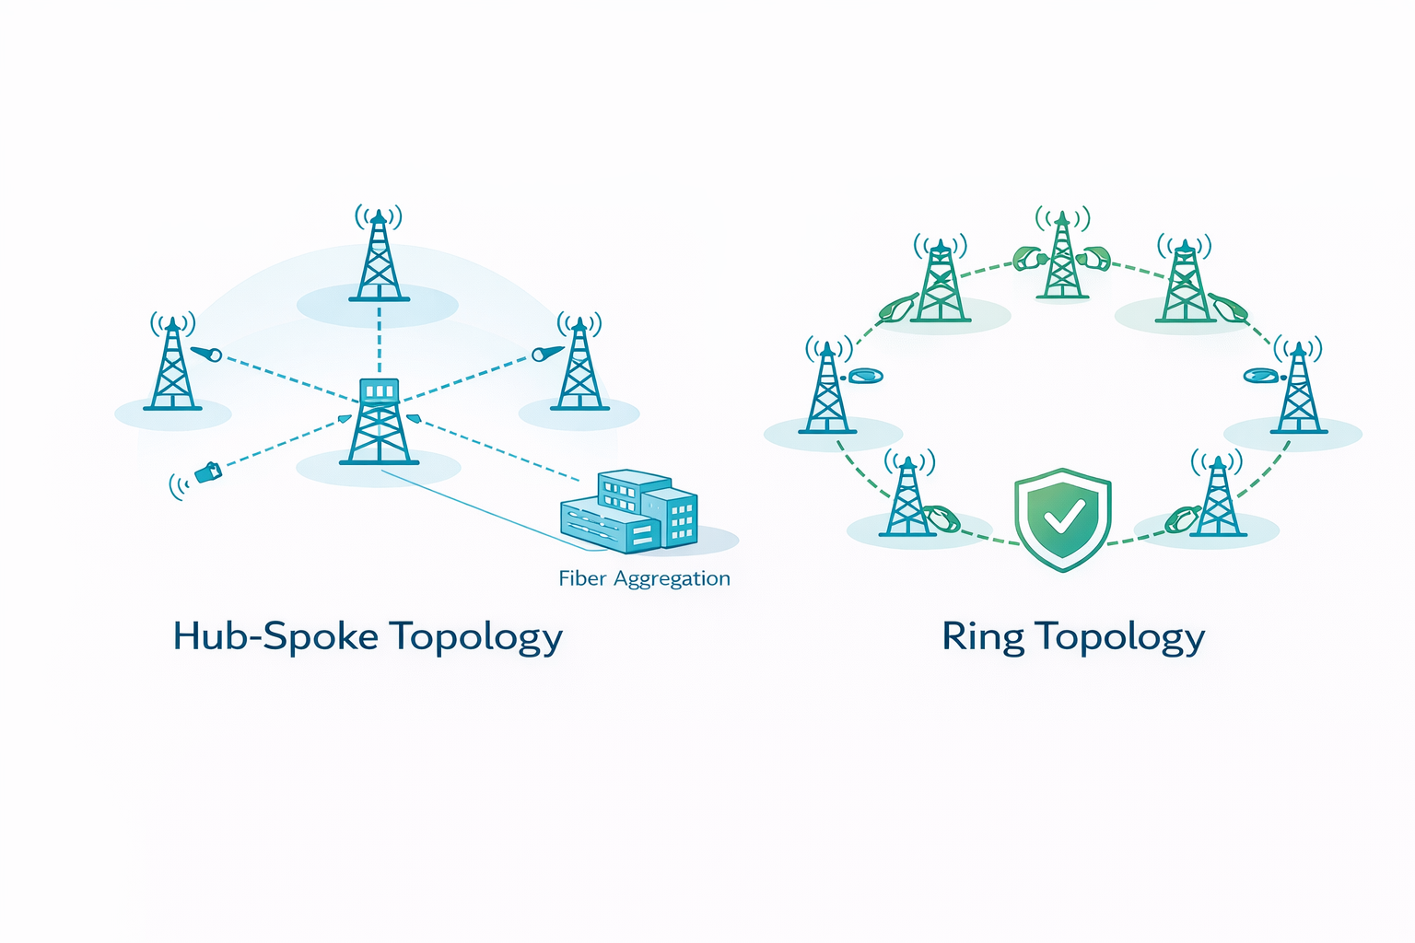
The 60% tower colocation scenario aligns perfectly with hub-spoke topology. Existing towers already provide optimal mounting heights and proven structural capacity. Simple point-to-point links from fiber aggregation hubs to each tower site create a straightforward, maintainable network.
For critical aggregation nodes or high-subscriber-density locations, selective deployment of ring topology provides path diversity and 99.99%+ availability through automatic failover.
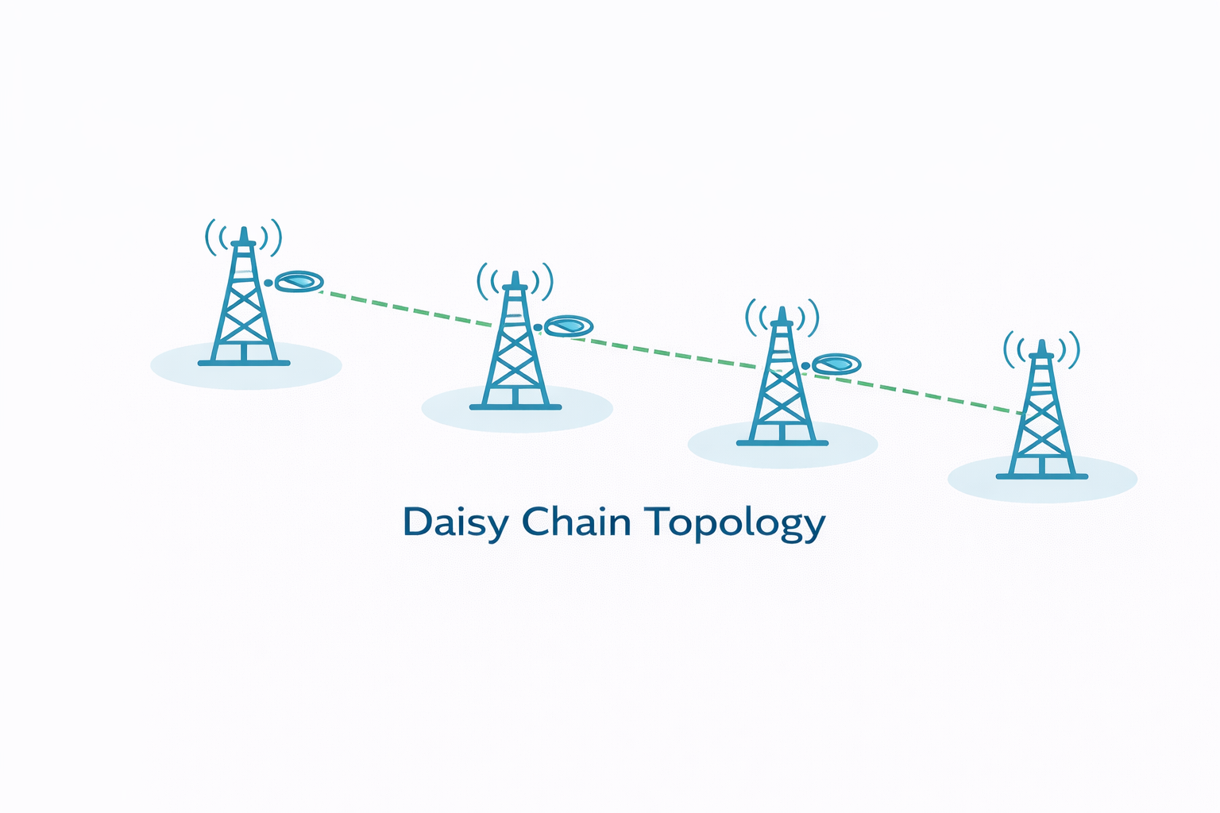
This requires dual radios per site but delivers carrier-grade reliability for revenue-critical infrastructure. Deploy rings strategically rather than network-wide to optimize cost-performance balance.

PLANNING & DESIGN METHODOLOGY

Six-Phase Delivery Process
Our planning and design methodology follows a proven six-phase approach ensuring comprehensive requirements capture, accurate technical design, regulatory compliance, and seamless handover to deployment teams. The structured process balances efficiency with thoroughness, typically completing full planning and design for a 20-site rural network within 16-20 weeks. Each phase produces specific deliverables with customer acceptance criteria before advancing to subsequent activities.
Phase | Duration | Key Activities | Primary Deliverables
Phase 1: Initiation & Requirements | 1-2 weeks | Stakeholder alignment, requirements documentation, project planning | Requirements Specification, Project Plan, R&R Matrix
Phase 2: Desktop Analysis | 2-3 weeks | Terrain analysis, fiber vs. MW decisions, preliminary design | Solution Design Document, Network Topology, Equipment Count
Phase 3: Site & Path Surveys | 5-12 weeks | Physical site assessments, LOS verification, infrastructure evaluation | Site Survey Reports, Path Survey Reports, Photo Documentation
Phase 4: Detailed Design | 5-7 weeks | Link budgets, frequency planning, FCC coordination, equipment specs | Detailed Design Document, BOM, FCC Package, Configuration Sheets
Phase 5: Documentation | 1-2 weeks | Final documentation consolidation, quality control, BOM finalization | Complete Documentation Package, Procurement-Ready BOM
Phase 6: Handover | 1 week | Knowledge transfer, design review, formal acceptance | Executive Summary, Knowledge Transfer Session, Completion Report

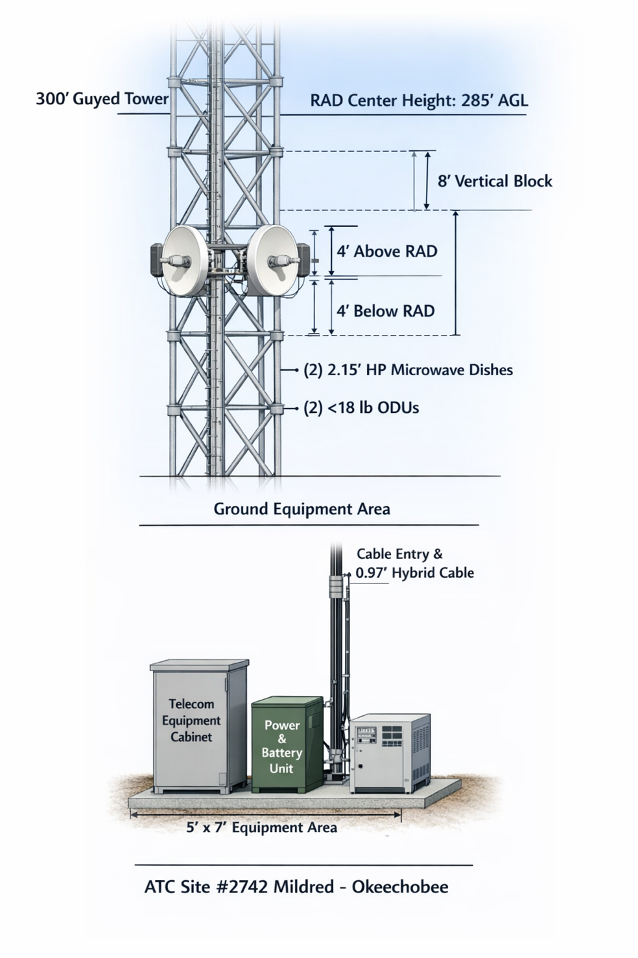
Feet | Inches | Metric | Industry Name
1 ft | 12 in | 0.3 m | 0.3 m dish
2.15 ft | 26 in | 0.6 m | 0.6 m dish
3 ft | 36 in | 0.9 m | 0.9 m dish
4 ft | 48 in | 1.2 m | 1.2 m dish

